I was just about to send you this email with some additional information and suggestions for how to proceed.

1. We need to determine which parts of the structure are giving rise to which features of the diffraction pattern. It is already clear that the peak at 3.4 Å is essentially only from the stacked bases, and then primarily from the orientation when the main axis of the structure is perpendicular to the x-ray beam. By subtracting the pattern of the 16 mer hexaplex without the Glu side chains from the pattern of the full 16 mer hexaplex, we can see that the broad peak at 7.25 Å (in the experimental data) is likely from only the backbone atoms. The other three peaks, at 3.7, 4.4 and 5.6 Å, appear to have comparable contributions from both the backbone and the Glu side chains.

It would be great to have a better idea of which particular atoms are giving rise to these features. The big questions that I would like to answer are, Does this pattern confirm that we have β-sheet backbone confirmations? Does this pattern reveal the spacing of the backbones and, in particular, does this pattern confirm that the spacing is not uniform, with neighboring backbones alternating between H-bonding and being too far apart for H-bonding (as our model predicts).

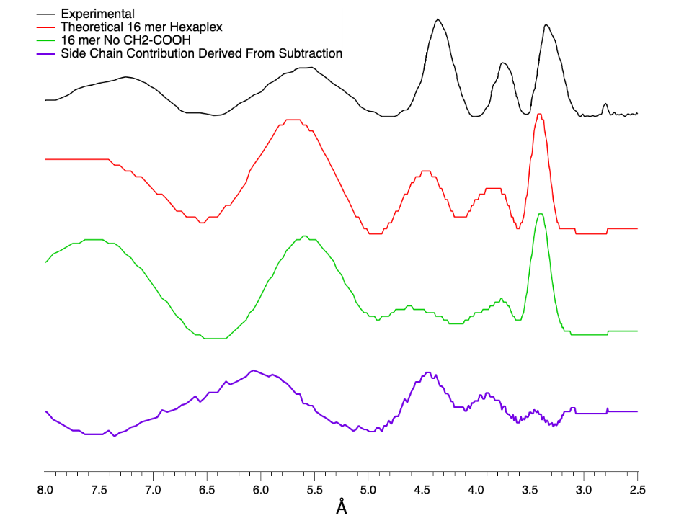

2. How specific is this diffraction pattern to a particular model? Can we use comparisons between model patterns and the experimental data to prove that we have anti-parallel strands? To what “degree" can we constrain the helical twist of the structure? The model with anti-parallel strands and 30° twist already looks quite good. However, we can ask: Does minimization or systematic search of models with distance constraints derived from the experimental data converge on a structure with a refined helical twist and backbone spacing that fits the data even better? Overall, how unique is such a fit and how much can it constrain our model?

3. Quantitatively, what does the diffraction pattern tell us about the stacking of MULTIPLE assemblies? How regular is the registration of the helical twist between stacked assemblies? What is the approximate length of assemblies within the sample? As you can see below, my modeling of the 4-hexad, 8-hexad, and 16-hexad assemblies clearly supports there being stacking of the 4-hexad assemblies within the sample (as also indicated by gel electrophoresis and Mass Spec). Going a little further, I think these simulations support the stacks containing at least 4 registered assemblies, as the 8-mer assembly does not reproduce the features of the experimental data as well as the 16-mer model. I have not run a longer model, but it would be good to do so and seen at what length the pattern stops changing and if the pattern converges at some length with the experimental data.

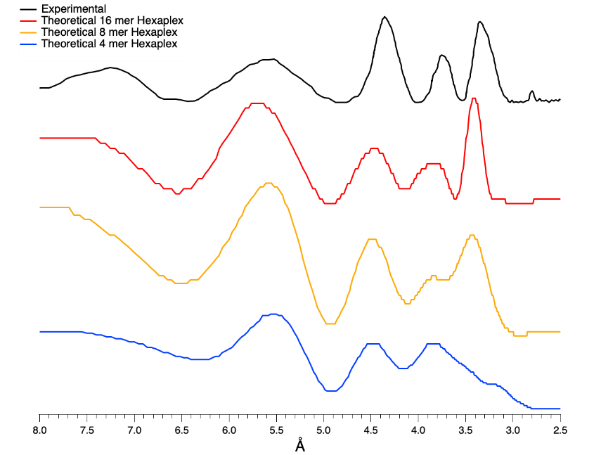

Here is some information about the way I have simulated the powder diffraction data. Our original fiber diffraction program was perfect for this task!

My input files have the main axis of the hexad stack horizontal with respect to “our world”. Thus, we can enter 0° for the Tilt of the assembly, which keeps the axis of the assembly parallel to the horizontal axis. Here is the pattern that is obtained for the initial state, before rotation about the vertical axis. This would be the pattern for a perfectly aligned fiber.
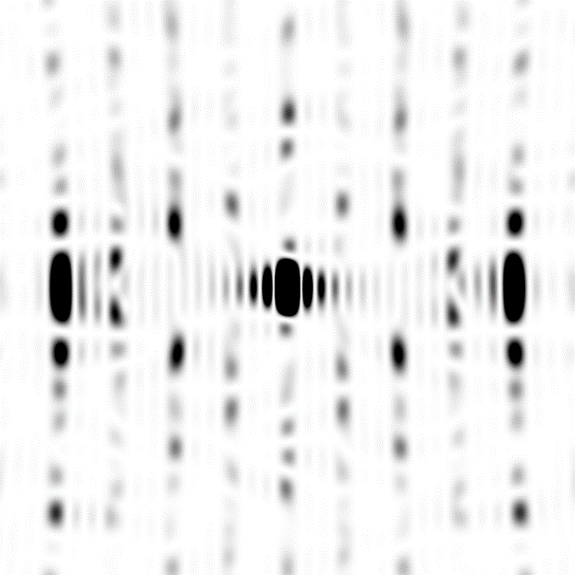

Note that these pre-rotated/pre-spun patterns could prove helpful for determining which features in the powder pattern are coming from the bases versus the backbone.

For generating powder diffraction patterns, the model is rotated in 5° steps about the y axis with the pattern generated and summed at each step (as we did in our previous simulations). Here are the parameters I used in the program for the simulations I am sharing.
# Specify the tilt and rotation series
tilts = [0] # Degrees. The rotation of the whole fiber with respect to the incoming light beam
rotations = range(0, 5, 180) # Degrees. The rotation of the whole fiber around its axis

Notice that I only rotate to 180°. That is because I symmetrize the pattern upon “spinning” the image, so we are averaging out any asymmetry that we have by not collecting patterns from the rotation angles from 180 to 360°. Importantly, I also found the rotating less than 5° between pattern collection did not change the results much. There was a noticeable, but relatively small, difference between a pattern from 5° rotation and a pattern from 10° rotation, so I went with 5° rotation.

This 180° rotation in steps of 5° about the y axis provides a pattern like this:

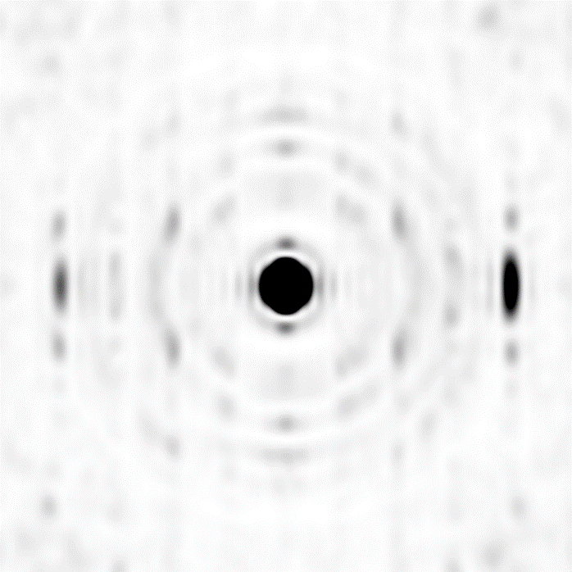

Finally, I added to the code a couple lines in which the diffraction images, like the one above, are rotated about their centers and averaged.


I have attached my modified Python program named diffractionnvh1.ipyb and the modified Python subroutine file named scripspowder1.py
Also included are a few .xyz structure files and a text file with the powder diffraction data profile.

Just let me know when you would like to talk.

Nick

From: Asem Alenaizan <alenaizana@gmail.com>
Date: Friday, June 19, 2026 at 2:45 AM
To: Hud, Nicholas V <nick.hud@chemistry.gatech.edu>
Subject: Re: Modeling Powder Diffraction Data
Hi Nick,

This is great! Yes, please share with me your input files and I can play with the parameters to see if we can shift the peaks slightly. It already match it pretty well.

Regards,
Asem

On Fri, Jun 19, 2026 at 4:46 AM Hud, Nicholas V <nick.hud@chemistry.gatech.edu> wrote:
Hi Asem,

I have done some modeling of the powder diffraction data, and the results are very encouraging. Would you be interested in doing some model refinement to make an even better match with the data? The model peaks are already within 0.1 Å of the experimental values, based on your idealized anti-parallel 30° twist model.

Nick

